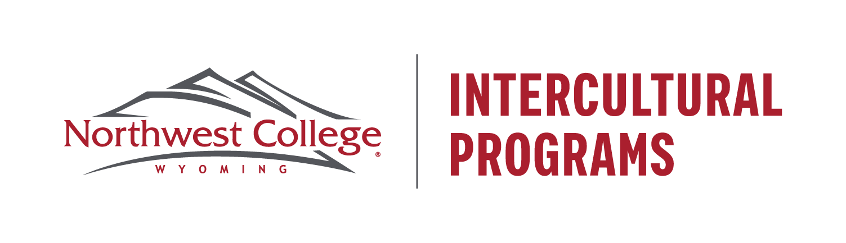

Agent Contract Agreement

*JBS Global LLC &*

*Northwest College*

Agreement of right of representation between Northwest College (NWC) on behalf of the Office of Intercultural Programs (hereinafter called OIP) and JBS Global LLC (owners of the brands Elite Euro Talent & Blusoar) hereinafter called JBS hereby witnesseth as follows:

1. The OIP hereby appoints JBS as a non-exclusive representative and hereby grants JBS the non-exclusive right to advise prospective students into NWC programs.
2. JBS shall agree to provide to prospective students full and accurate information about NWC, including but not limited to its enrollment procedures; costs for tuition, fees, room and board, and incidental expenses; academic offerings; and facilities. Further, JBS agrees to comply with all applicable policies, statutes, ordinances and regulations in connection with Northwest College and OIP.
3. Northwest College shall provide to JBS a supply of brochures and other promotional material and upon request shall replenish said supply.
4. Northwest College conditionally authorizes JBS to use the official seal and logos of NWC in JBS promotional literature of NWC programs. Authorization is conditioned upon written approval from the OIP for every instance of any such use prior to publication. The OIP grants JBS permission to use only the name, Northwest College.
5. In consideration for its service to NWC, OIP shall pay JBS 15% of NWC’s tuition for one year for each student it enrolls. OIP will pay the 15% upon completion of the students’ first semester, after receiving an invoice from JBS. At this time, should the student have an unpaid tuition balance, NWC may withhold payment until student balance is paid in full. In addition, should the student give any indication that they will transfer to another institution after the first semester at NWC, we may withhold payment to JBS.
6. JBS acknowledges and agrees that it is an independent contractor and is not an employee of NWC for any purpose whatsoever.
7. This agreement shall be construed in accordance with the laws of the State of Wyoming.
8. JBS hereby acknowledges reading and receiving a true and exact copy of this Agreement and that it contains all the terms and understanding between NWC’s Office of Intercultural Programs and JBS.

In witness whereof, and intending to be legally bound hereby, the parties hereto have executed this agreement on the 01 day of March, 2023.

**JBS Global LLC.** **Office of Intercultural Programs, NWC**

By: _______________________________ By: ________________________________

Title: ______________________________ Title: _______________________________

Date: ______________________________ Date: _______________________________

Northwest College | Intercultural Programs | 231 W Sixth Street | Powell WY 82435-1895 USA

tele: (307) 754-6424 | fax: (307) 754-6245 | e-mail: international@nwc.edu